Operating Instruction

Of

2BYSF-N bucket wheel corn precise seeder

2BYSF-N
2—seeding and fertilizing
B—Seeding
Y—corn
S—Spoon wheel
F—Fertilizing
N—Rows number (2, 3, 4)
Contents
- Safety warning marks …………………………………………………2
- Using and Characteristics………………………………………3
- Using…………………………………………………………3
- Characteristics……………………………………………3
- Main technical specification…………………………………4
- Working principle…………………………………………………6
- Structure and function …………………………………………7
- Installation and adjustment……………………………………9
- Installation……………………………………………………9
  - Installation example of 2BYSF-2………………………10
  - Installation example of 2BYSF-4………………………11
- Adjustment of rows spacing …………………………… …11
- Changing over between one seed in one hole and double seeds in one hole………………………… ……………………………………12
- Adjustment of plant spacing …………………………………12
- Adjustment of depth ……………………………………………13
      - Adjustment of fertilizing depth …………………13
      - Adjustment of seeding depth ………………………13
- Adjustment of seeding quantity ………………………………14
- Adjustment of fertilizing quantity…………………………15
- Adjustment of tightness degree of chain …………………15
- Operating and safety items …………………………………………16
- Loading seeds and loading fertilizer………………………16
- Clear fertilizer and seeds …………………………………16
- Break seeding way in remaining rows ………………………17
- Working………………………………………………………………17
- Removing of common faults …………………………………………18
- Technical maintaining and safe-keeping…………………………20
- Technical maintaining…………………………………………20
- Safe-keeping………………………………………………………20

一.SAFETY WARNING MARKS

1. This kind of warning mark is on both sides of fertilizer hopper, which could remind the workers what should be noticed.
When the machine is raised maintained or adjusted, it should be locked to avoid the dangerous of extrusion.
2. This warning mark is on both sides of fertilizer hopper, which could remind the people around what should be noticed.
Don’t close to the machine when it goes up and down, avoiding the dangerous of extrusion or impact.
3.This warning mark is on the protected chain box, reminding the workers what should be noticed.

Don’t open or pick off the protective cover when the machine is working, avoiding the dangerous of twine.
4. This warning mark is on the front of fertilizer box, which the tractor driver could see it in the obvious place when he looks back.

二.USAGE AND FEATURE

- Usage
This machine is matched with tractor for working, mainly used for precise sowing single seed or double seeds corn in no-tillage field, can drill graininess fertilizer, which can finish furrowing channel for fertilizer , furrowing seeds channel , sowing seeds, covering, pressing etc during one operation.
- Feature
1. Discharging seeds machine has precise sowing rate, the standard seeds index number is up to above 80%.
2. Adopt normal filling seeds, could work with high speed, when the plant space is not less than 20cm, working speed could reach 8km/hour.
3. Holes spacing is precise, plant is even-distributed, small competition, individual advantage could be given full development, vigorous crops, high harvest.
4. Equipped with single seed and double seeds two kinds of guiding seeds wheel, when the user-seed is the handpicked seed, it should be chosen single guiding seeds wheel, in order to come true the one hill one seed precise sowing, not handpicked seeds should be chosen double guiding seeds wheel, in order to come true one hill two grains sowing.
5. Each line’s axis of rotation is linked to an entirety，unified driving, rotate speed is uniform, big transmission power , even one ground wheel skids occasionally, it won’t affect normal sowing seeds.
6. Whole machine goes through unique speed changing box to change plant spacing, it could generate four kinds of plant spacing, only changing the transmission ratio of the speed changing box, it could change each line’s row spacing of the whole machine.
7. The speed changing box performer stick could simultaneously control the swaying and moving wheel to sway radially and axially, operation is fast and convenient, all the gears of speed changing box are chosen superior quality steels that through carburizing process, every transmission component is chosen superior rolling bearing, performance is reliable.
8. The rack is raised from the ground, the front and back furrowing channel’s distance is dilated, it alleviates the phenomenon that summer sowing wheat straw blocks the machine.
9. Selected the large output volume’s discharging fertilizer box, emboldened the transporting fertilizer tube, the maximum discharging fertilizer volume could reach 80 kg/mu.

三． MAIN TECHNICAL SPECIFICATION

model | 2BYsF—2 | 2BYsF—3 | 2BYsF—4
Overall dimensions L*W*H(mm) | 1440×1150×980 | 1440×1500×980 | 1440×1950×980
Weight(kg) | 140 | 190 | 270
Driven power kw (hp) | 8.8～13.2  (12～18) | 11～18.3  (15～25) | 18.3～29.4  (25～40)
Working rows | 2 | 3 | 4
Row spacing (mm) | 428～630 | 428～800 | 428～570
Plant spacing (mm) | 120、165、180、225、250、310
Qualified rate of plant spacing | 85% | 85% | 85%
Depth of furrowing channel (mm) | 60～80 | 60～80 | 60～80
Sowing depth of fertilizer (mm) | 60～80 | 60～80 | 60～80
Depth of sowing seeds  (mm) | 30～50 | 30～50 | 30～50
Max volume of fertilizer  (kg/mu) | 80 | 80 | 80
Volume of seeds (kg/mu) | 1.5～2.5 | 1.5～2.5 | 1.5～2.5
Breakage rate of seeds (%) | ≤3 | ≤3 | ≤3
Capacity of fertilizer tank (L) | 42 | 68 | 86
Capacity of seeds tank (L) | 8.5×2 | 8.5×3 | 8.5×4
Allowed max working speed of single seed model(km/h) | 4.0（plant spacing 120㎜）  5.8（plant spacing 165㎜）  6.4（plant spacing 180㎜）  8.0（plant spacing 225㎜）  8.9（plant spacing 250㎜）  11.0（plant spacing 310㎜）
Pure working efficiency hm²/h | 0.2～0.3 | 0.3～0.45 | 0.4～0.6
Minimum distance of transportation from ground | 300㎜ | 300㎜ | 300㎜
Minimum, horizontal and vertical distance between  seeding bed and fertilizing bed (mm) | ＞50 | ＞50 | ＞50

四.WORKING PRINCIPLE
Emphasizing introduction of discharging seeds organization’s working principle

This discharging seeds machine mainly includes: discharging seeds body, guiding seeds wheels, clapboard, discharging seeds bucket wheel, cover of discharging seeds machine etc. Clapboard is installed between discharging seeds-body and discharging seeds cover, they are relatively motionless. Corn discharging seeds bucket wheel is installed on the guiding seeds wheel, circular clapboard is located between the discharging seeds wheel and guiding seeds wheel, it has around 0.5gap with them, making the relative rotation won’t occur jam, seeds go through discharging seeds machine cover limited entering discharging seeds machine underneath’s putting seeds area when it is working, making the bucket wheel fulfil seeds. Bucket wheel and guiding seeds wheel are clockwise rotation, making the bucket wheel type hole of filling seeds area get further step filling seeds, seeding bucket pass filling seeds enter clearing seeds area, bucket wheel fill in surplus seeds is in a not stable condition, under the action of gravity and centrifugal force, the redundant seeds are divorced from the bucket type hole, fall back to filling seeds area, when seeding bucket wheel turn into discharging seeds machine, that is the separating seeds board’s passing seeds hole, seeds in the gravity, the centrifugal force function, fell into a seed bucket and the corresponding guide wheel in a groove, seeding bucket finish passing seeds to guiding seeds, seeds enter into protected area, continue turning to the discharging seeds cage’s opening place, seeds fall into the seeds channel which furrowing channel machine have furrowed well, finish discharging seeds.

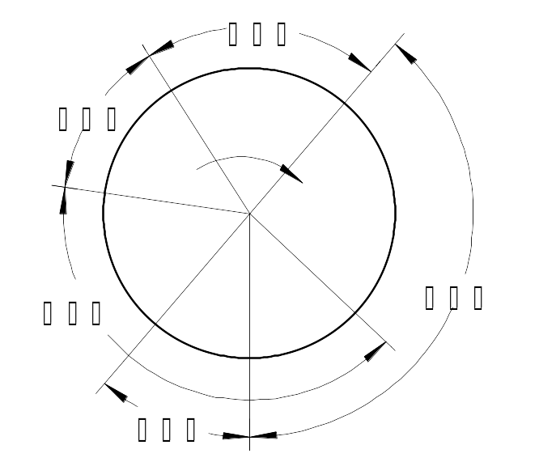
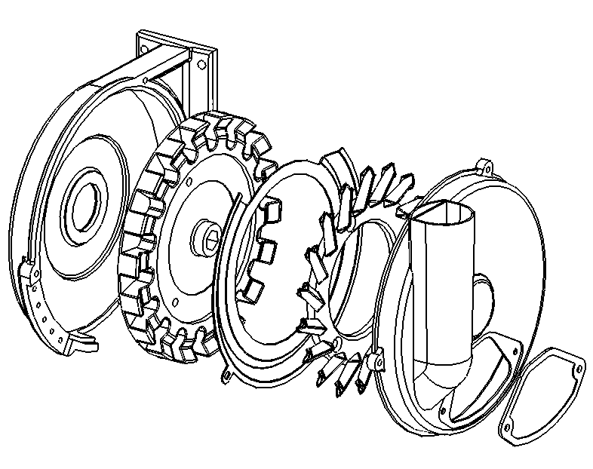
Body of seeds discharging device
Seeds guide wheel ssfdfddseed
Clapboard

Bucket wheel of seeds discharging

Cover of seeds discharging device

  - sowing seeds machine exploded structure chart b. working process chart

Chart 1, principle of seeds discharging picture

五．STRUCTURE AND FUNCTION
Such as picture 2 shows this machine mainly included by this five parts: rack (picture3), anti-wind fertilizer furrowing channel device (picture 4), seeding assembly (picture 5), transmitting system (picture6), fertilizing hopper assembly.

Chart 2. Structure of the whole machine

Transmission system

Seeding assembly

Frame

Anti-wind furrower

Pull-board of gearbox
图2、整机结构图

1.ground wheel 2.axle of ground wheel 3.Wear-resisting cover 4.soil cover device 5.furrower 6.seeds discharging machine 7.seeds transporting tube 8.furrowing channel coulisse 9.bracket

10.small linkage box bottom, cover 11. seeds hopper, cover of the seeds hopper 12bottom and cover of big sprocket wheel 13 organization of limiting depth 14.draw bar

Chart 5 Seeding Assembly
1.ground wheel axle 2. differential sprocket 3.chain102 section 4.gear-box 5.hexagonal hole, 18teeth sprocket 6.hexagonal axle282 7.hexagonal hole 36 teeth sprocket 8.carden、9.sintered metal powder bearing 10.hexagonal axle590 11.hexagonalaxle357 12.fertilizer discharging axle 13.fertilizer discharging18 teeth chain wheel 14.fertilizing chain 86 section 15.double unite chain wheel 18/36 teeth 16.chain 40 section 17 seeds discharging 18 teeth chain wheel 18.seeds discharging chain 46 section 19.seeds discharging machine 20.hexagonal axle 430
Chart 6 transmission mechanism

六．Installation and adjustment
（一） Installation
This product has many kinds of machine types, if according to line number, there are two lines, three lines, four lines and so on, each type could choose their own fertilizing organization, it can add covering film system on the two lines- machine. The method of installation is mainly same as different machine type, front-axle beam of rack is installed anti-wind furrowing channel machine, back-axle beam of rack is installed every seeding assembly, among the seeding assembly there one equips with speed changing box, fertilizing hopper is installed on the rack. The installing method of three-line machine could reference picture 2 and picture 6. The installing method of two-line machine could reference picture 7. The installing method of four-line machine could reference picture 8. When installing, needing pay attention to the following points:
1、The seeding opener must be stagger to above 50mm with the fertilizing opener in the left and right direction, avoiding to the fertilizer burns the young plant.
2、When installing each seeding assembly, you need to try your best to keep every corresponding axle and hole are concentric, the two ends of U type wire should screw alternately, while screwing the U type wire, observing the interval of assembly and the rack bridge, guarantee it is complete anastomosis with bridge’s surface.

chart 7. 2BYSF-2 installation picture
Driven shaft 590

Driving shaft 730

Chain 68 sections

Chain 38 sections

Transitionaxis of fertilizing

Pull-board of gearbox

Fertilizer tank shaft

Driven shaft 430

Driven shaft 430

Driving shaft 430

Chain 40 section

Transitionaxis of fertilizing

Pulling plate of gearbox

Chain 67 section

Driven shaft 520

Driving shaft 590

Driving shaft 520

Chart 8. 2BYSF-4 installation picture

（二）Adjustment of rows spacing
The First step, loosen each U type wire of assembly, then loosen the pulling board U type wire of speed changing box.
The Second step, loosen the flat clips of the variable speed changing transmission shaft. (Four flat clips)
The Third step, loosen the top wire of fertilizing chain wheel. (Except the 2BYSF-3 )
The fourth step, each assembly is axial movement, with the fertilizing chain wheel, chain. (Except the 2BYSF-3), after reach the target of the rows spacing, tightening the loosened screws of the front steps.
The fifth step, adjust the fertilizing furrowing channel’s position.
(三) Switching the mode of one hole one seed with the mode of one hole double seeds.
When this product leaves factory, seeds discharging implement should adjust to be the mode of one hole double seeds, if the user need one hole one seed mode, also could operate with following the below steps:
The first step, twisting three M6 bolts of around the seeds discharging implement cover, taking down the seeds discharging cover.
The second step, twist the three M8 countersunk head screws of the fixed bucket wheel, detach the bucket and clapboard.
The third step, twist center’s M8 bolt of the seeds discharging implement, detach the double grain guiding seeds wheel.
The fourth step, after change the seeds discharging wheel of single seed, then install the dismounted components of front steps to their suitable position.

Double seeds guide plate

M6bolt

Single seed guide plate

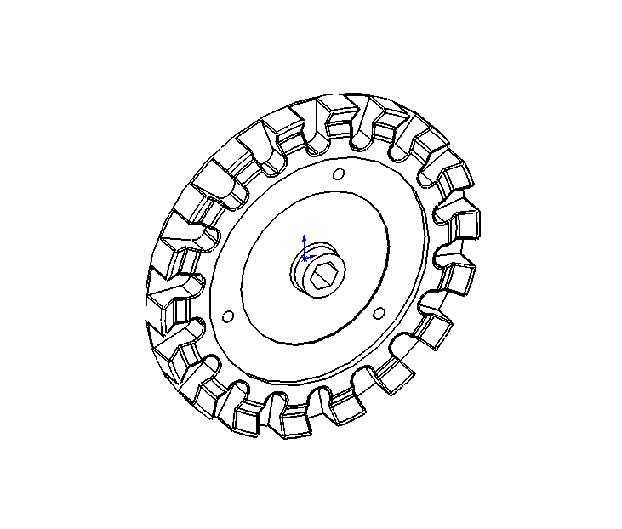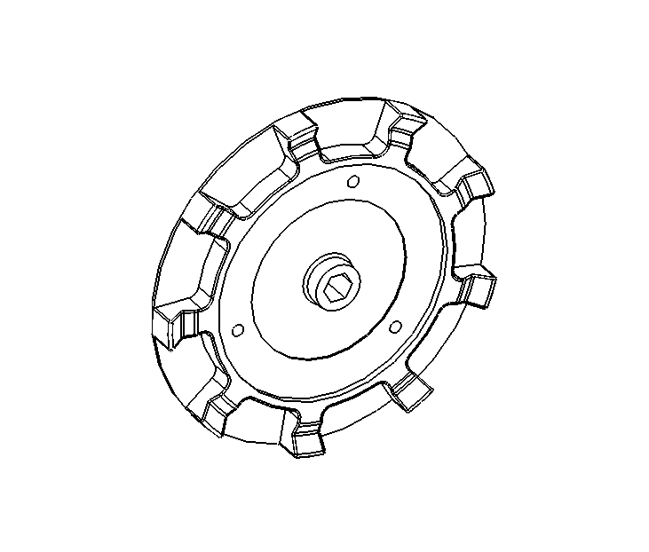
First gear groove

Second gear groove

Third gear groove

Fourth gear groove

Output shaft

Indicator bar

Hand bar

Empty gear groove

Input shaft

Chart 10 adjustment of plant spacing

M8 bolt

M8sunk screw

chart 9 switching the mode
（三）Adjustment of plant spacing
Adjusting the transmission ratio
of the speed changing box could change the whole machine’s each plant spacing, when operating, pull down the hand lever, make the pointing lever to be in the neutral position groove, then operate the hand lever right and left to see the changing position. When the index lever reaches the entrance of chosen file position, loosen the hand lever, index lever will enter the neutral position groove automatically.
Parameter of plant spacing table unit: (mm)
model condition | First gear | Second gear | Third gear | Fourth Gear
Single seed model | 280 | 226 | 173 | 140
Double seeds model | 560 | 452 | 346 | 280
Comment: the above row spacing is theory row spacing, if the earth’s surface is soft, the ground wheel with mud will magnify the row spacing relevantly.
If the above row spacing couldn’t meet your need, you can ask for help to our company.
（四）Adjustment of depth
1. Adjustment of fertilizing depth
Loosening fertilizer furrowing channel U silk, moving plough up and down to adjust depth, moving up to shallow, moving down to depth. Requiring fertilizer furrowing channel machine’s under point ligature is parallel with machine rack, suggesting fertilizer furrowing channel machine is deeper 50mm than seeding furrowing channel machine, achieving deep fertilizer.
2、Adjustment of seeding depth
Like table 11 show, rotating the hand wheel clockwise, the ground wheel will lessen, furrowing channel machine will raise, sowing depth will decrease, conversely, sowing depth will

a, operating way for smaller seeding depth
b, operating way for bigger seeding depth
Picture11. The adjusting method and principle of seeding depth
If the requirement of each line’s depth is inconformity, can loosen the two top screws of front upright, move the furrowing channel implement for seeding, realize this line’s adjustment of depth.
（五）Adjustment of seeding amount
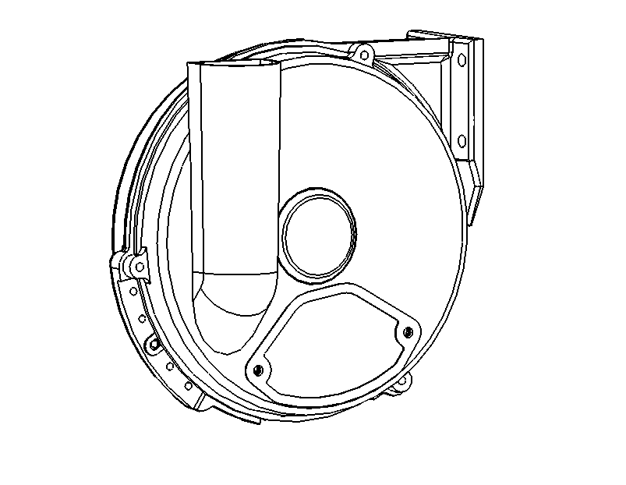
The seeds discharging
chart 11, adjustment of seeds rate
Positioning ear of clapboard

up

down

of this product is precise seeds discharging machine, in normal condition, empty hole rate won’t exceed 5%, repeating seeds won’t exceed 10%. If meet the special seeds, or the user has special requirements, according to the method of picture adjust the seeds discharging machine. Move up the chucking lug of clapboard, repeating seeds rate will be lower, but empty holes rate will be raised. Move down the chucking lug of clapboard, empty holes
rate
will be lower, but repeating seeds rate will be
raised. User should adjust the test again and again, till reach the satisfaction.
（六）Adjustment of fertilizing rate
Empty the inner fertilizer of the fertilizing discharging box, loosen the butterfly nut of the axle end, rotate the hand wheel to change the axle direction working length of the outer groove wheel axle, come true the adjustment of the fertilizing rate, after finished, screw the butterfly nut.
Rotate the hand wheel anticlockwise, groove wheel’s working length will be short, fertilizing amount will be reduced.
Rotate the hand wheel clockwise, groove wheel’s working length will be dilated, fertilizing amount will be increased
(七）、The adjustment of link chain’s elasticity
1. The main link chain is adjusted by the regulating wheel.
2. When adjusting the seeds discharging chain, may loose the four installed bolt of the seeds discharging machine, moving the seeds discharging machine up and down, could change center distance of the two chain wheels to reach the adjusted aim.
3. The fertilizer of discharging chain could through moving the position of fertilizing hopper front and back to change the center distance to reach the adjusted purpose.
Notice: As the seeds discharging chain is vertical chain, when installing must keep tensioning condition, usually checking the chain’s tensioning condition when working, if find it is slack, you should tighten it timely.

七、Operating method
（一）、loading seeds and loading fertilizer
Griddle the smash and sand etc tiny particle of the inner seeds, pick out the corn core, weeds, mark and paper etc block sundries, the seeds are scattered then picked up, must clean and choose, then could load, the seeds with cloth should make sure it is dry, soaking seeds or bag buds seed’s moisture should be controlled below 50%.
- Before loading seeds should check: whether the clearing seeds covering cap is covered well, whether the both ends of the grain tube is connected well, if find problems should reject the back could load seeds timely.
- After adding the seeding box should cover the seeding box’s cover well, couldn’t open it when working.
- Working time, should observe the position of inner seeds in the grain tube, when the up plane closes to the bottom of the tube, should add seeds timely, or it will be leaked seeding.
- Smash the packing fertilizer, pick out the sundries, the too watered and poor mobility fertilizer should dry in the sun in advance.
- Before loading the fertilizer, should have a check to see whether there are sundries in the hopper, after loading, check whether the bottom of the pulling board is open.
（二）clean fertilizer and seeds
- Open the putting fertilizer’s covering cap of the fertilizer’s hopper bottom when clean fertilizer, most fertilizer will flow out of this place, residual fertilizer could take out the pulling plate of clean fertilizer entrance, open the clean fertilizer entrance then the residual fertilizer discharges, if needs you could take out the bottom iron wire of the fertilizer discharging box, then open the fertilizer discharging tongue, could clear up the fertilizer.
2．When clean the seeds, you should wipe out the mud which stick to the opener, and put a bag under the opener, take down the covering cap of clean seeds, make the seeds flow out, if the seeds couldn’t flow out, you may use your finger to dial-out, also may one hand catch the bag, one hand rotate the ground wheel, till clean up the seeds.
（三）、Break seeding way in remaining rows
When working field appears remaining rows, like, there are 8 rows in one field, using 3-row seeding machine could work twice then finish 6 rows, leave 2 rows, it is not enough to have one work, so appears remaining rows, now we need break seeding one or several seeding assembly. This product equips with clutch on the transmission shaft of seeds discharging, could make the seeds discharging plate and transmission system separate or connect conveniently.
（四）、Working
- Forbid exceeding the following working speed
Plant spacing（㎜） | 160 | 200 | 260 | 325
Allowed the working speed (km/h) | 4.0 | 5.0 | 5.5 | 6.0
- When the machine is driving on the road with high speed, must lock well the lifter of tractor, prohibit the stretch implements travel.
- Keep the machine slow and stable, avoiding the jam of entering earth in opener.
- Need specially-assigned person follow the machine and monitor: whether the seeds discharging plate and the fertilizer discharging wheel are regular rotation, whether the machine will be jammed by the stem in the front, whether the depth of seeding is suitable, whether there is the phenomenon of lost seeds, if has problems, need remove them.
- Before each working time or changing field need check and repair, middle of working time also should break seeding and examine and repair regularly, the way and content as follows:
  - Raising the machine and rotating the ground wheel, observing whether discharging seeds is normal.
  - Checking the fertilizing and seeding opener, see whether they are blocked.
  - The sticky earth of driving wheel’s periphery is too much, should clean up.

八、Removing of common faults
Fault name | Fault reason | Removing method
Ground wheel slips | Discharging seeds chain is loosening | Tighten the discharging seeds chain
Ground wheel slips | Ground wheel is too high | Rotate the turning deep hand wheel clockwise
Ground wheel slips | Opposite installation of Differential-speed mechanism | Raise machine, reverse every ground wheel, when we find it has big resistance, we should change the direction of differential mechanism.
Ground wheel slips | The front of machine is low and back of machine is high | Lengthen the center draw bar of the tractor
Each line’s depth is not identical | Depth of seeding opener is not identical | Loosen the bolt of furrowing channel machine, move the furrowing channel machine up and down.
Each line’s depth is not identical | Fertilizing opener entering earth’s angle is inconformity. | Loosen the U bolt, adjust the angle when entering earth.
Seeding rate is too big | Grain tube is fall off, clearing seeds covering cap is drop | Connect seeds tube well, cover the clearing seeds entrance well
Seeding rate is too big | Exceed the limited speed | Reduce the seeding speed or adjust the plant spacing much bigger
Empty hole or leak sowing | Seeds discharging device has abnormal things or it is abnormal | Take out of the abnormal things
Empty hole or leak sowing | Bucket wheel is stick filled by pesticide | Clean the bucket wheel
Empty hole or leak sowing | Clapboard’s position is over high | Turn down the clapboard
Empty hole or leak sowing | Discharging seeds chain drops | Hang the chain well
Empty hole or leak sowing | Driving wheel’s tighten nut doesn’t work | Tighten the tighten nut
Empty hole or leak sowing | Short of seeds in the seeds discharging device or seeds are overhead in the seeds pipe. | Add seeds, or shake and clean the seeds pipe
Empty hole or leak sowing | Clutch separating | Resetting clutch
Leak seeds | The seeding depth is too small | Adjust the seeding depth
Leak seeds | The angle of covering device is not proper. | Adjust the soil covering disc
Leak seeds | The entering soil angle of furrow is too big | Adjust the middle draw-bar
Off chain frequently | Wear seriously of sintered metal powder bearing | Change sintered metal powder bearing

九、Technical maintaining and Safe-keeping

（一）Technical maintaining
- After each class finish working, clear the mud of parts of machine.
- On the day after work,clear all the fertilizer in the cylinder of fertilizer, pick off the discharging seeds disc to clear residual seed;
- Usually checking the fastening condition of every link components, if has loosening condition, we should tighten it timely.
- Inspecting every turning part whether they are flexible turning, if not normal, we should adjust and clear the stoppage timely, if the heavy abrasion with the wear proof knot, we should change it immediately.
- The discharging fertilizer chain wheel block groove should be added butter one time every four hours working, we should paint butter chain link and fly wheel constantly.
（二）Maintaining
- After season of sowing in the year, clear every part’s mud and remnant seed-fertilizer, then put them on the dry place, keep them out of sun.
- All the chains should be taken off from the machine, after butter, put them in the plastic bags for specialized keeping.
- Take off each discharging seeds plate, clear them, covering plastic bags for key point keeping.
- Each lubricating point, should fill butter, plough curve and the furrowing channel machine should keep with butter.
- Repair or change the damaged and worn components timely, repaint the paint removing parts.

