1）: Warning
1:For the first 50 hours, please don’t let it running at full capacity.
2: Please change engine oil after 50 hours.
3: Don’t let it running in low or high speed for long time, keep normal please.
4: Keep it with no load running for 3-5 minutes.
5:If there is something wrong with it, stop it and eliminate it. Don’t keep it working with troubles.
Don’t keep it running with no body around.
6: Stop it normally.
7: Make sure water for water tank is clean.
8: Use the right and clean engine oil and diesel oil, change engine oil regularly.
9: Fill engine oil in ail filter and clean it and change engine oil regularly.
10:Prohibit water in the intake and exhaust value.
11: When the tempreture is ＜0°C, get out the cooling water.
12:Don’t let child, the old be around when it is running.
13: Don’t use it when drunk.
14:Keep inflammable far away from the engine.
15:Make sure stop it before fill diesel oil.
16: Make sure it is adequate ventilation of the yard when it is running.
17: Make sure stop it before overhaul.
18: Don’t touch high temperature parts when it is running or just stops.
19: Pay more attention when get the engine oil out; get the cooling water out when the engine is cooled down.
20: Hold tidely the hand shank when start it.

2）: engine oil
1:Use CC-30 or CC-40 engine oil when local temperature is ≥0°C, use CC10W/30 when local temperature is ＜0°C.
2：Get the scale out and fill clearn engine oil around 2.5 kg, check the oil level between the 2 lines.
(Photos for view.)
3: Don’t fill too much over the top line, when it’s lower the bottom line, please fill it, keep the oil level between the 2 lines.

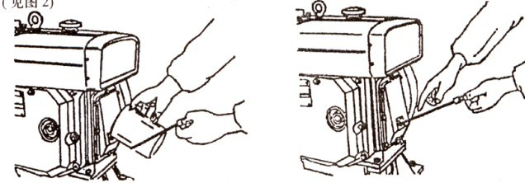

3）: Diesel oil
1: Use #0 when local temperature is ≥0°C, use #-10 or -20 when local temperature is ＜0°C.
2: fill clean diesel oil like the photo 3
3: Get the air out from the tube.(it it ok when no bubbles of flowing diesel oil) . photo 4.

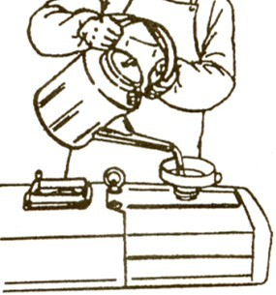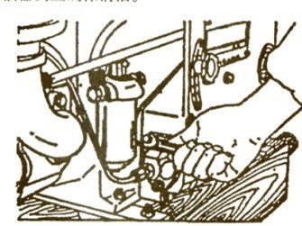
photo 3 photo 4

4）: cooling water
Use clean soft water as cooling water, fill the water until the floater can not going up.

5): diesel working
1: after starting, please check the red mark of engine oil indicator valve if going up, if not, please
stop the machine and fill more engine oil or eliminate the defect.
2: when it is working, the cooling water should be in boiling state. And please add water timely.
3:when there is black smoking, please make it lesser loaded or stop it for defect elimination.
4:If there is strange noise of the machine,please stop it and eliminate the defect.
5:After first 50 hr, please check and tiden all the blots and nuts.
6): stopping of diesel
1: Before stop it, keep it running serval minutes with no loaded.
2: When emergency stop needed, block the inlet tube of air filter with towel. (see photo please)
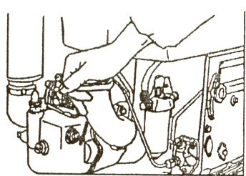

7): tips of after stopping of diesel
1:turn off the oil tank.
2: for a long time no working or in winter, get out the cooling water to put it away.
3: Clean the water chamber regularly.
4: Close the inlet and exhaust valve (photo).
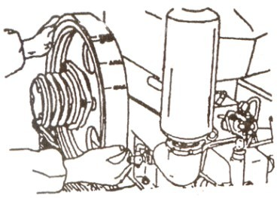

8): maintenance
1: adding cooling water according the above mentioned situation.
2: adding engine oil every day (according the above mentioned situation).
3:.oil strainer: after the first 50 hours, change new engine oil and clean the oil filter
Afterwhile, change new engine oil and clean the oil filter every 100hr.
4: air filter: after the first 50 hours, change new engine oil and clean the oil filter
Afterwhile, change new engine oil and clean the oil filter every 100hr.
5:diesel filter: clean the core with diesel oil, when the core is broken, change it timely.
6: nut of cylinder cover: after the first 30 hrs, check and make it tight.
7: oil tank: clean it with clean diesel every 50hr.
8: adjust the valve clearance every 100 hr.

